# Introduction

The ancient Chinese sage Confucius once said, "Teach students according to their aptitude"，Therefore, we divided our audience into four groups based on thier ages. Then we peovide diverse knowledge in different way according to their features.

# Primary School

## Qiushan Primary School

In China, instead of taking a specific “biology class”, students who at a young age usually have a "science class", which covers physics, chemistry and biology. Aiming to provide the younger group with an early and independent concept of “biology”, our team members decided to provide a vivid lesson to the children in primary school. So we contacted Qiushan Primary School in Deqing County through College of Bioengineering, Zhejiang University of Technology. In view of their lacking in biological knowlege, we decided to use a more concrete and visual way to help them with establishing basic biology conept, for example, slides and model-making.

At 2 pm on September 28th, our team members arrived at Qiushan Primary School. We taught the children about DNA and genetic variation. Then we used the questions we prepared in advanced to test their understanding about our lessens. And we are happy to see each question received positive response. After that, we started to make Zika models with them. We chose Zika because its model is simple and easy to make, and doesn't have sharp horns which is suitable for our young listeners. We hope that by making models, children can better understand what microbes are and our lesson can attract them to explore the mistry of biology and contribute to the development in biology in the future.

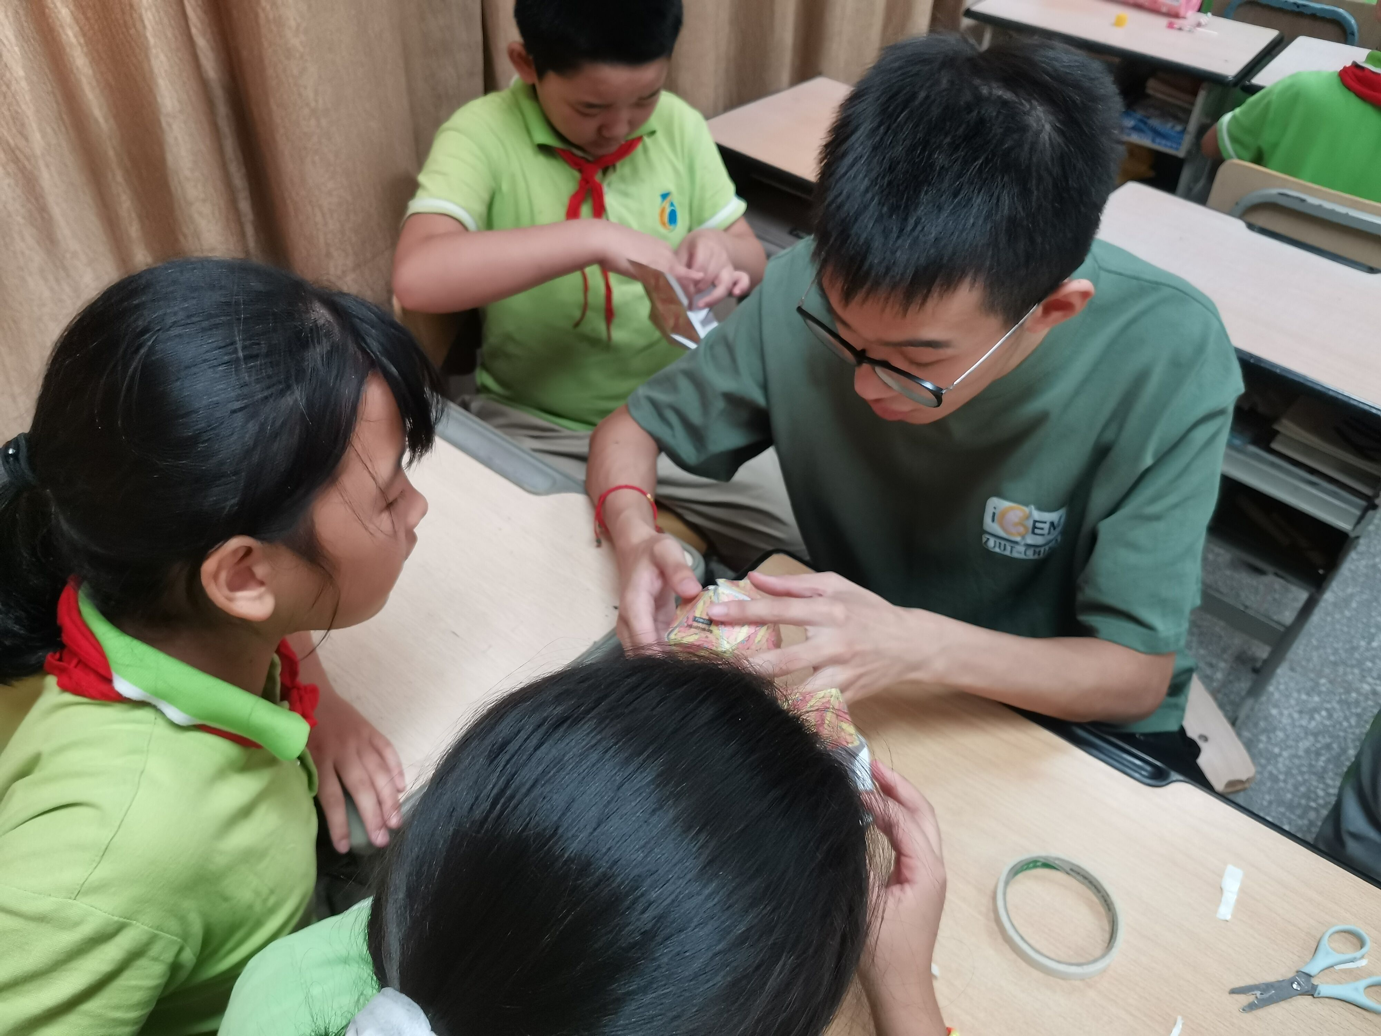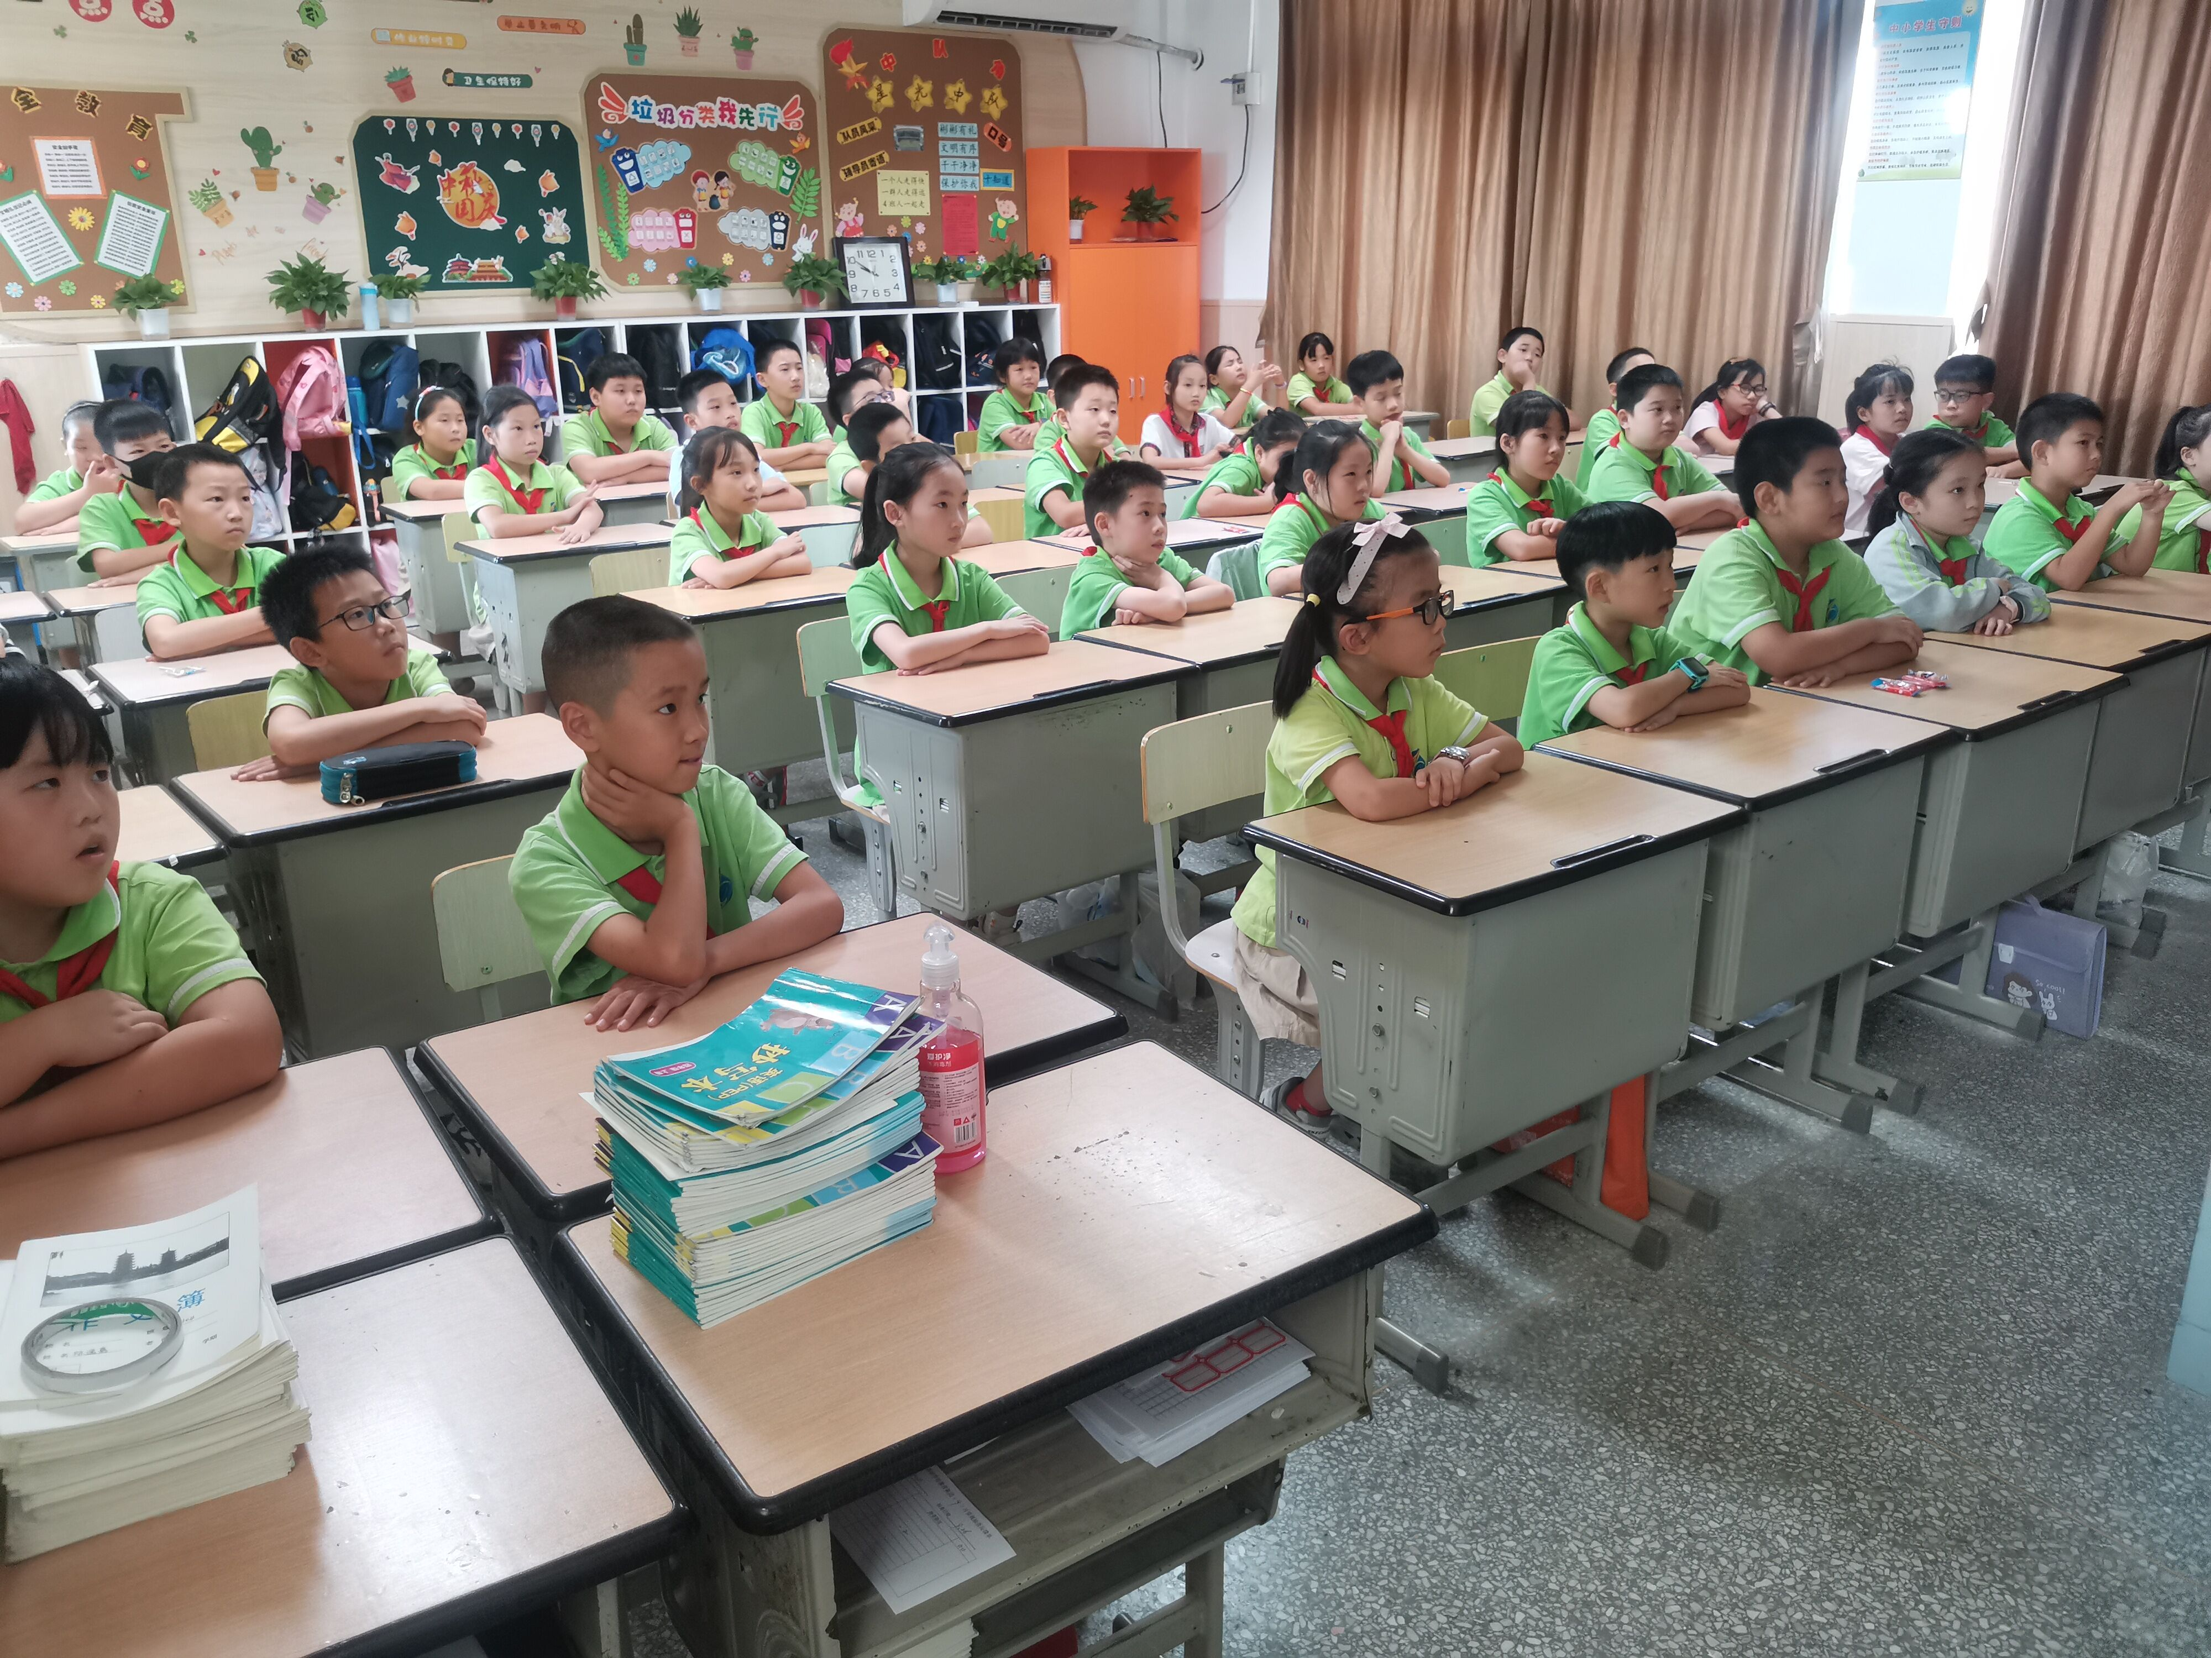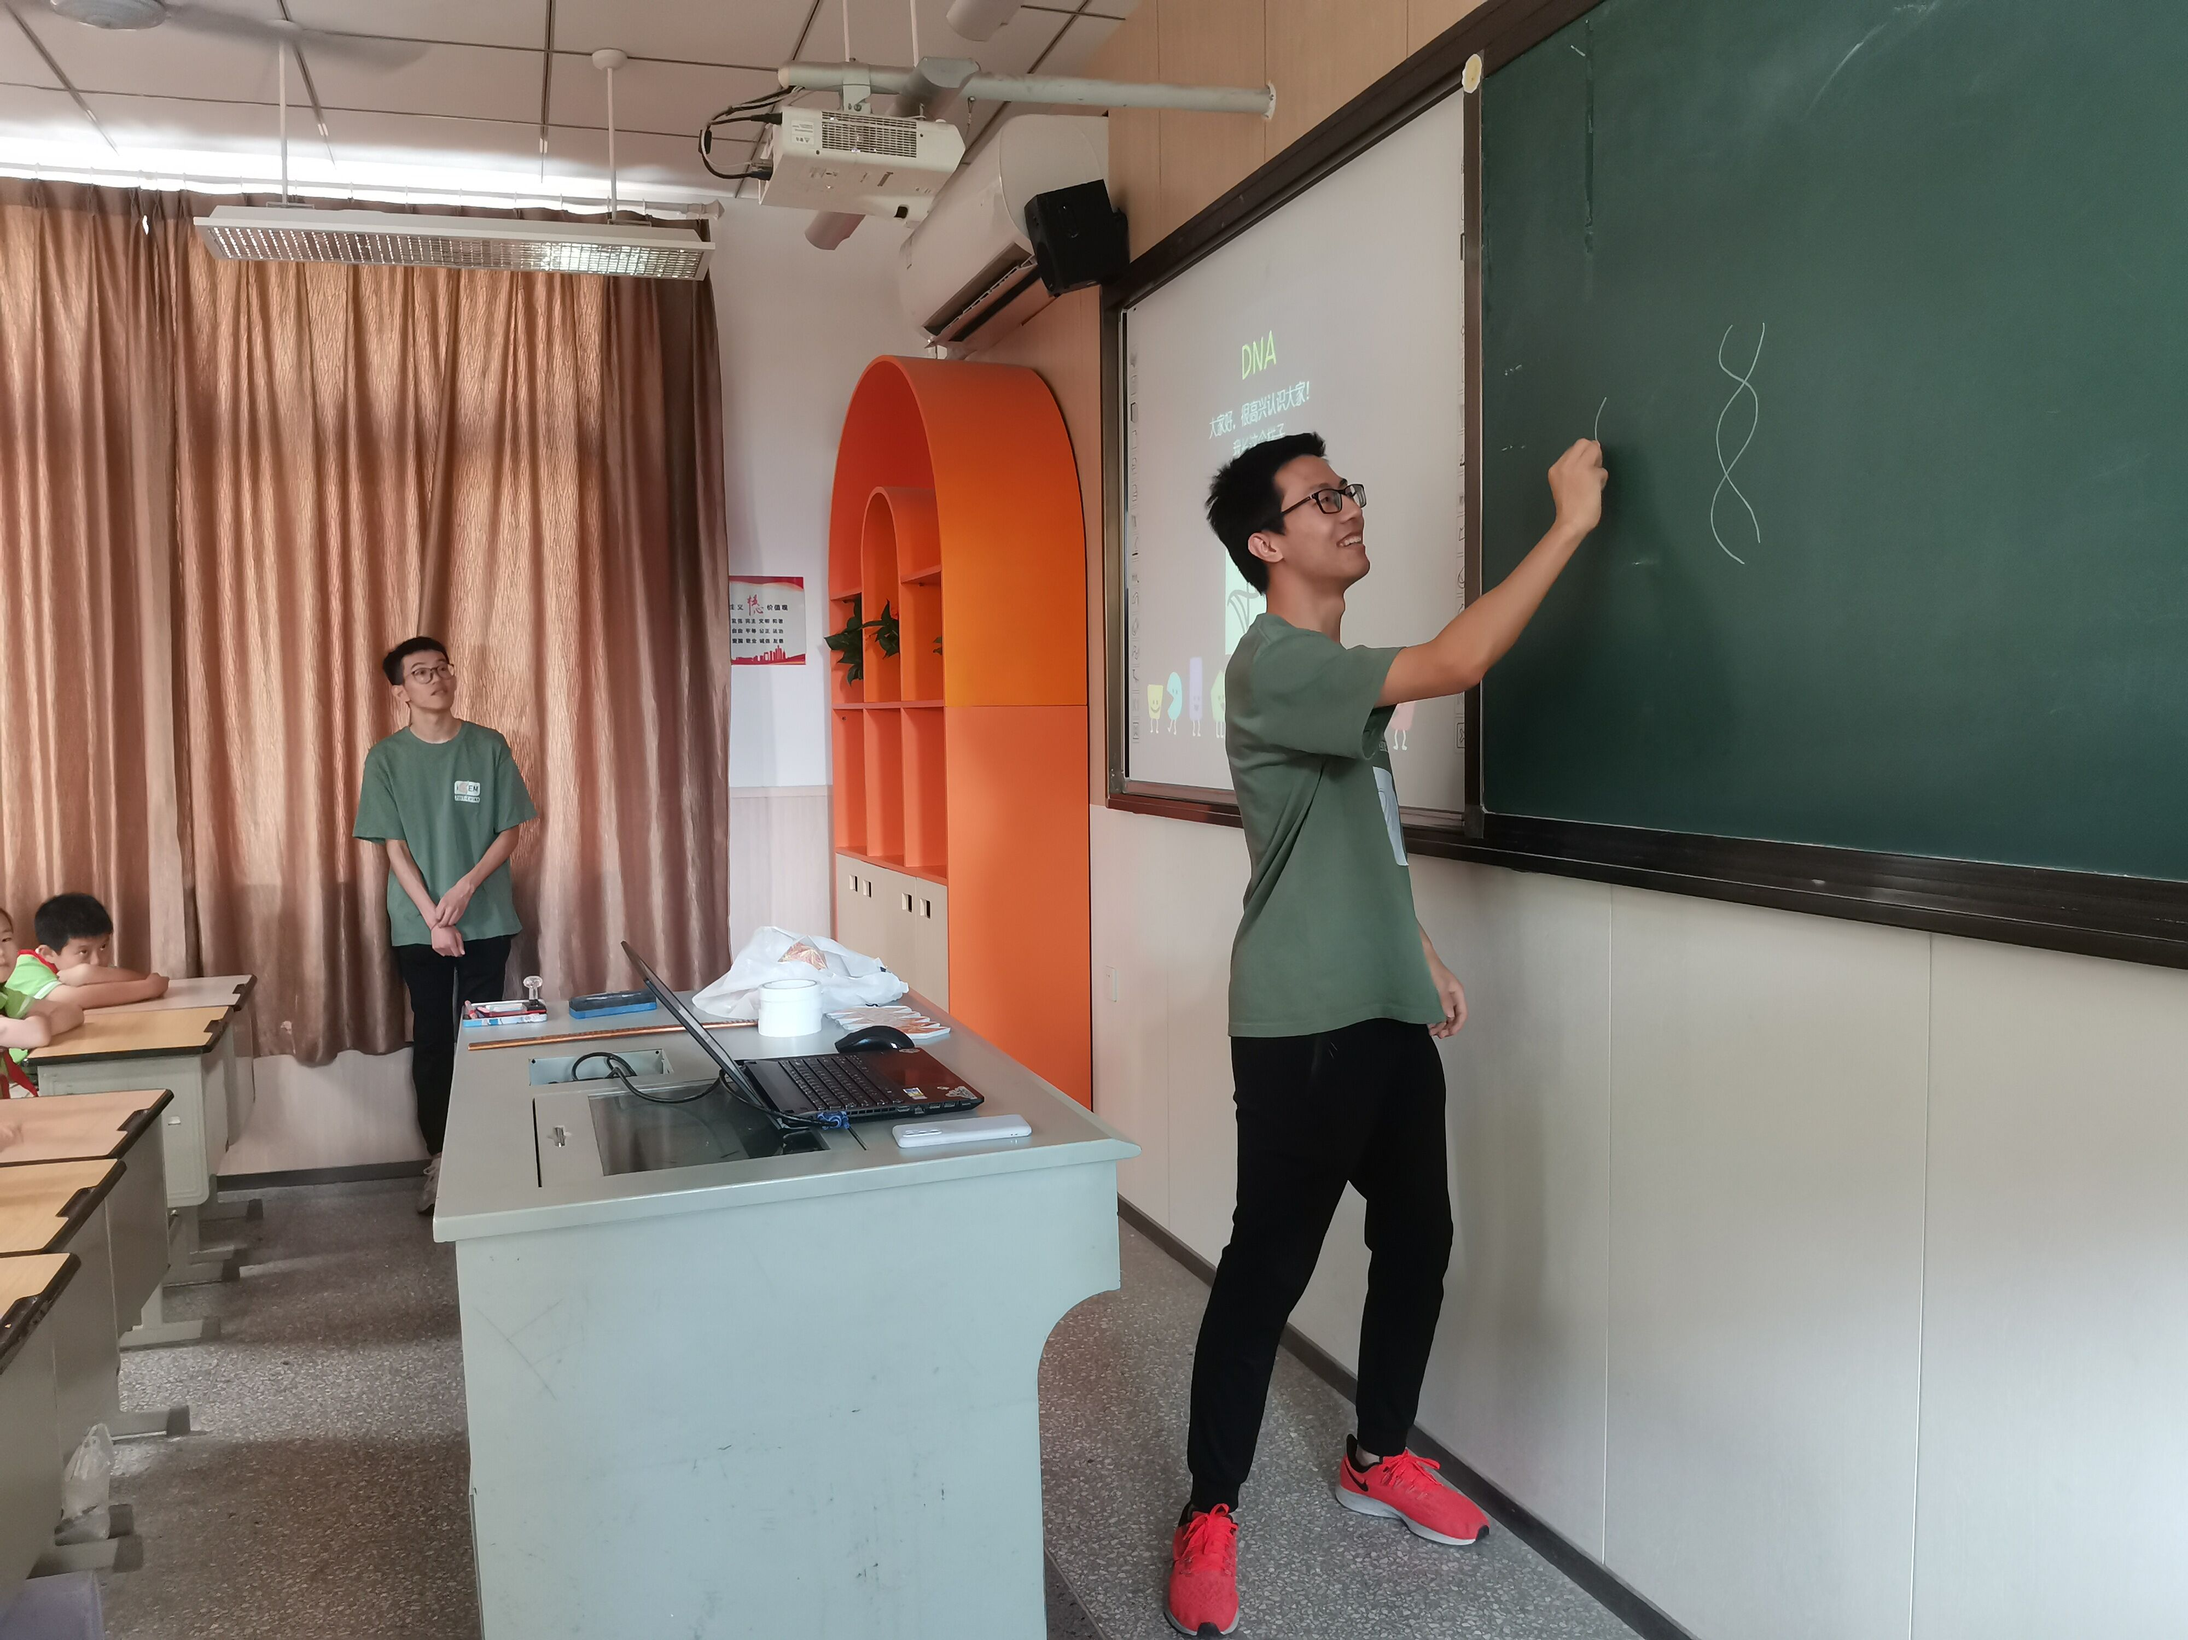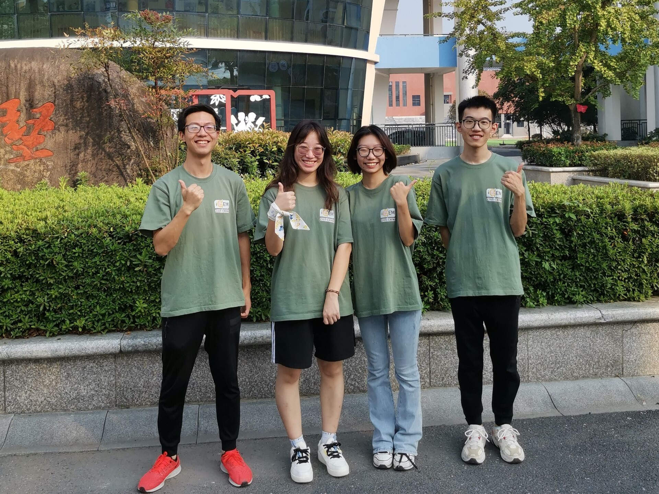

# Middle School

## High School Summer Camp

Compared with primary school students, middle school students already have basic understanding of biology, so we can explain our work to them in a more professional way. On August 29th, we participated in the summer camp for senior high school students sponsored by College of Bioengineering, Zhejiang University of Technology. We explained the mechanics of our program to the high school students in an appropriate language. After the summer camp, those students benefited a lot and had a deep understanding of our program and the differences between high school and university.

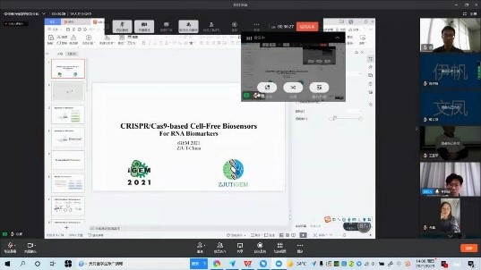

# College

Education for college students is mainly aimed at freshmen, who are new to college life, and a lecture can help them adapt to college life faster. We held the Study Forum and the Lab Open Day in May and September respectively.

## Study Forum

On May 9th, our team was invited by Study Forum to give a lecture related to the content of iGEM to the freshmen. As iGEMers and senior students, we shared with them our experience of participating in the competition and promoted iGEM as the top event in synthetic biology.

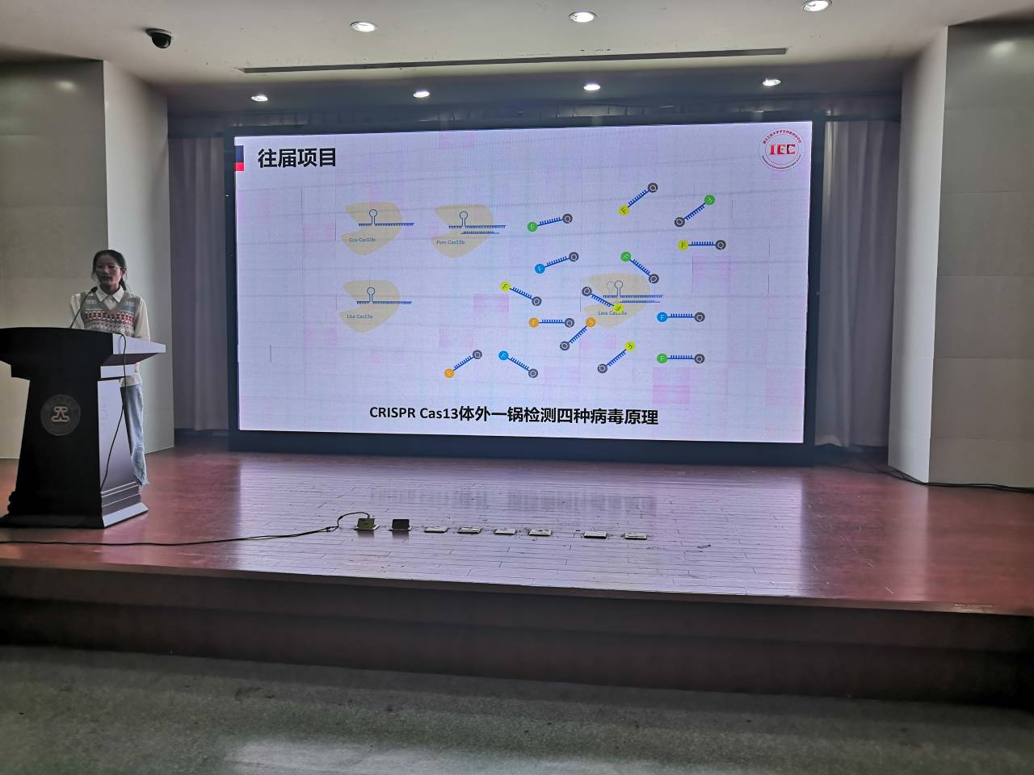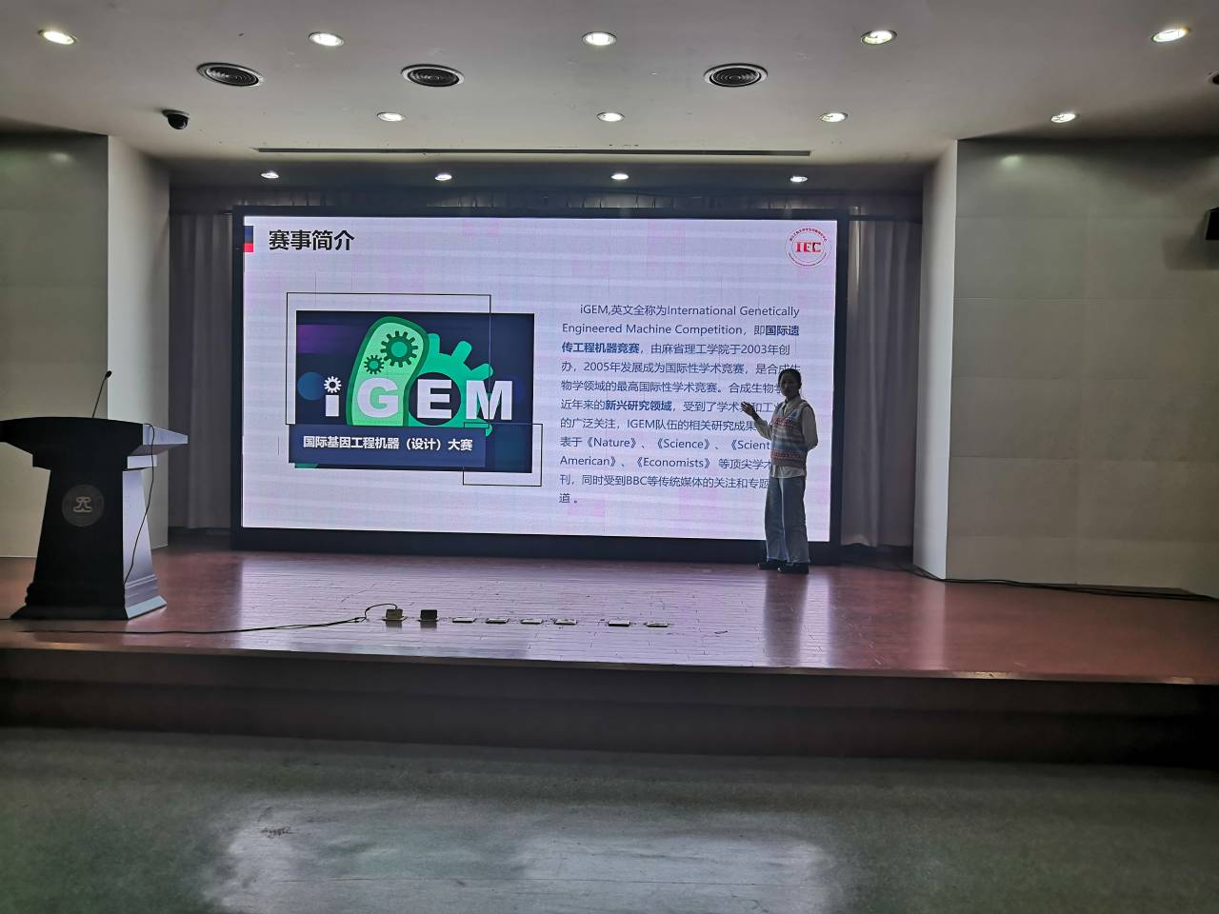

## Lab Open Day

In order to cultivate students' basic laboratory literacy and further promote iGEM, we held an lab open day for the freshmen in the afternoon of September 12. We prepared four separate programs: lab tour, agarose gel electrophoresis, use of pipettes and Culture media preparation. These are the most basic experimental operations that iGEMers do on a daily basis. Through this event, we collected students' first impressions of iGEM and their thoughts on the event, and improved their awareness of synthetic biology.

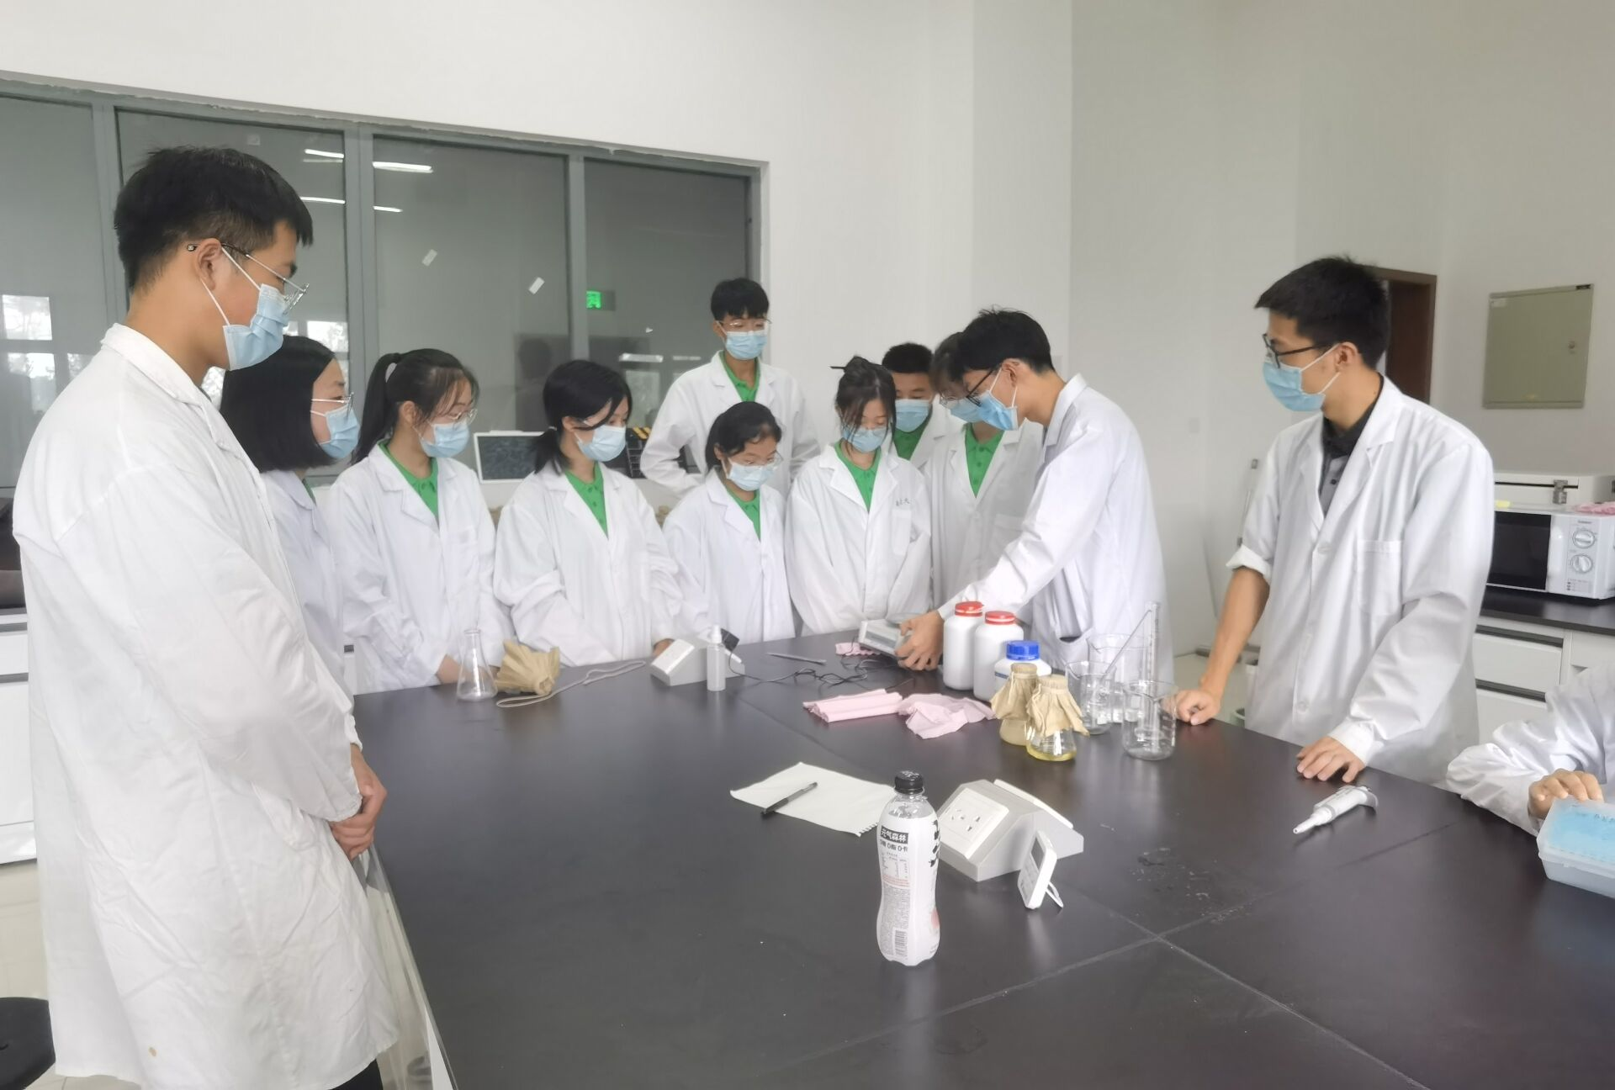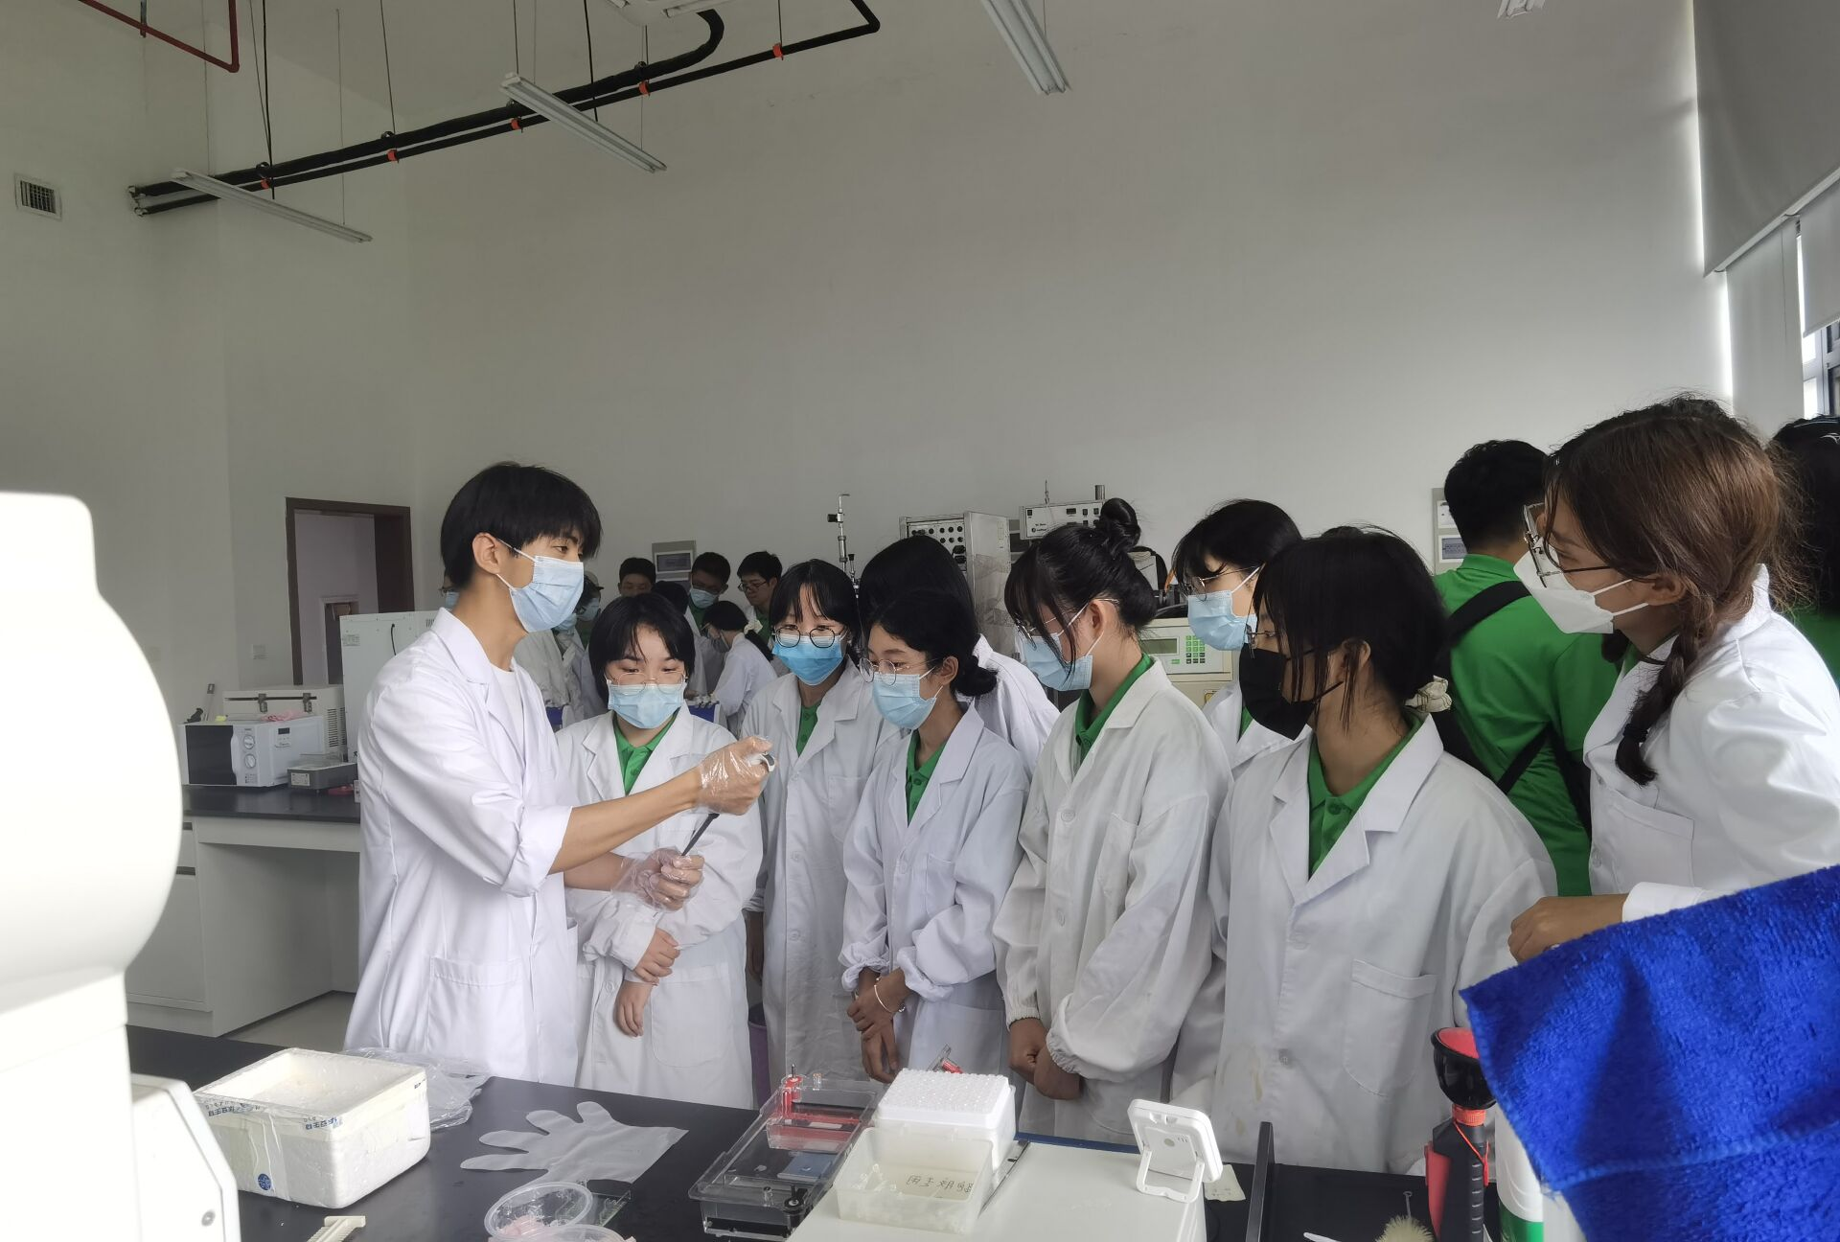

# All Ages

## Popular Science Publicity

WeChat is a Chinese multi-purpose instant messaging, social media and mobile payment app which has been described as China's "app for everything" and a "super app" because of its wide range of functions. Therefore, we paid much attention to the management of the WeChat public accounts. In addition to our daily progress notes, we also focued on using our public accounts to publish scientific articles that are closely related to the technologies we use, including but not limited to cell-free systems, Michaelis-Menten equation, etc. We have published 16 tweets on our public website, with a total of 461 followers.

